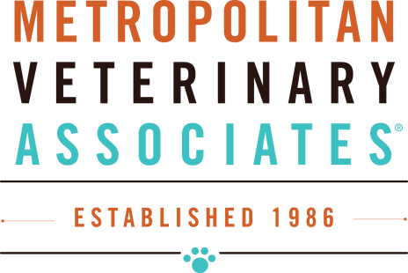
DERMATOLOGY RE-CHECK FORM
I understand that there is an EXAM FEE associated with this visit – please initial: ______

* In order to assess infection level, cytologies may be taken from your pet. If needed, are these cytologies authorized to look at? Yes No, we need to discuss first
Skin cytology (1) $45, (2) $67, (3) $79 Ear Cytology (1) $65
*Changes in general health since we last saw you? __________________________________
Are there other non-dermatological problems? ______________________________
* Medications (list all ORAL and TOPICAL medications)
MEDICATION DOSE (mg) FREQUENCY LAST GIVEN EFFECTIVE
________________________________________________________________________________
________________________________________________________________________________
________________________________________________________________________________
________________________________________________________________________________
* Have you missed doses? If so, which and when? __________________________________
* Have you run out of any medications? If so, which and when? _______________________________________________________________________
* Overall itch level 0 - 10 ____________
Focal spot/s___________________________________________________________________
* Strict Food Trial? Y N How Long? ______________________ Effective? Y N
* Allergy Vaccine? Y N Dose? ________________ How Often?_____________________
Last Given? ______________ If there is an increase in itch related to vaccine, is it before the injection is due or after it was given? __________________________________________
*Is your pet on flea and tick prevention? Y N If so, which one?
_________________________________________________________________________

